**D. Y. Patil College of College of Engineering and Technology, Kolhapur**

**Department of Computer Science & Engineering**

**Class: SY-A Subject: AOOC**

**Experiment no: 15**

**Group No. G20 Mini Project**

**Title of Mini-Project: Weather App**

**Problem Statement:**

**In an era of climate unpredictability, accurate and timely weather information is crucial for day-to-day planning and safety. However, many existing weather applications are either too complex, lack real-time updates, or are not tailored for localized needs. There is a growing need for a user-friendly, real-time weather application that delivers precise weather forecasts, current conditions, and alerts in a visually intuitive manner. This project aims to develop a responsive weather app that provides live weather data, 7-day forecasts, and weather-related alerts based on the user's location, helping individuals plan their activities and stay safe during extreme weather conditions.**

**Introduction:**

**Weather plays a vital role in our daily lives, influencing everything from travel plans and outdoor activities to agriculture and emergency preparedness. With the increasing frequency of sudden weather changes and extreme climatic conditions, having access to accurate and real-time weather information has become essential. Traditional weather forecasting methods are no longer sufficient to meet the fast-paced needs of modern users.**

**This project introduces a modern weather application designed to provide users with accurate, up-to-date weather data in a clear and user-friendly interface. By leveraging real-time APIs and location services, the app offers current weather conditions, hourly and weekly forecasts, and alerts for severe weather events. The goal is to enhance user awareness and preparedness by delivering reliable weather updates anytime, anywhere, on any device.**

**System Architecture:**

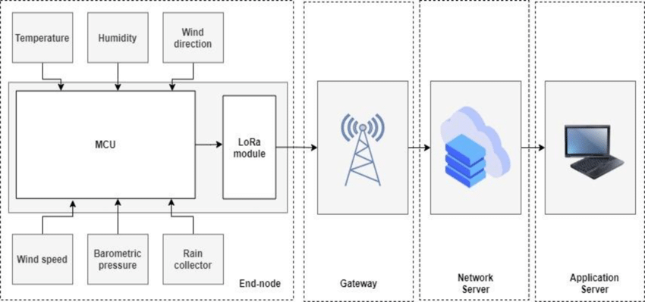

**Module description or working of system:**

**This project is a desktop-based weather application built using core Java concepts and Swing**

**for the graphical user interface. The app allows users to enter a city name and fetches real-time**

**weather data from a public API (like OpenWeatherMap). It is divided into the following key**

**modules:**

**1. GUI Module (User Interface Layer):**

* **Built using Java Swing.**
* **Provides a simple window-based interface.**
* **Includes:**
  + **A text field for city name input.**
  + **A button to fetch weather.**
  + **Labels or text areas to display weather details (temperature, condition, etc.).**
* **Designed to be clean and user-friendly for all age groups.**

**2. Weather API Module (Backend Logic Layer):**

* **Uses Java networking concepts (HttpURLConnection, BufferedReader) to send requests to a weather API.**
* **Parses JSON responses using libraries like org.json or Gson.**
* **Extracts required weather parameters such as:**
  + **Temperature**
  + **Weather condition (cloudy, rainy, etc.)**
  + **Humidity**
  + **Wind speed**

**3. Location Input & Validation Module:**

* **Takes user input (city name) from the GUI.**
* **Validates the input to avoid null or empty entries.**
* **Sends the valid city name to the Weather API Module for processing.**

**4. Data Display Module:**

* **Receives processed data from the Weather API Module.**
* **Updates the GUI with readable and formatted weather details.**
* **Displays error messages if data is not available or API fails.**

**5. Error Handling Module:**

* **Handles:**
  + **API connection failures.**
  + **Invalid city names.**
  + **JSON parsing errors.**
* **Provides user-friendly alerts or error messages using JOptionPane.**

**Screenshots:**

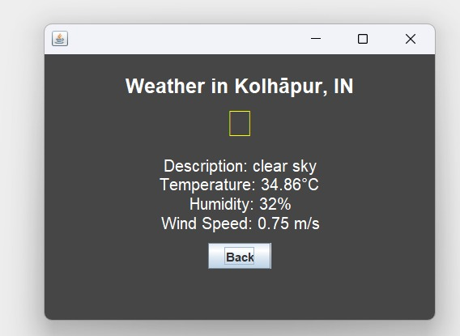

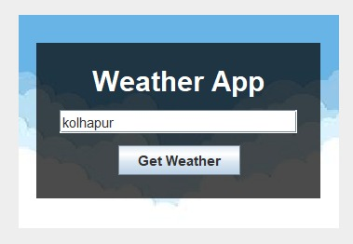

**Group Members:**

|  |  |  |  |
| --- | --- | --- | --- |
| **Unique id** | **Roll No** | **Name of Student** | **Sign** |
|  |  |  |  |
|  |  |  |  |
| **EN23209357** | **84** | **Divya Jitendra Sutar** |  |
|  |  |  |  |
|  |  |  |  |